

# External Documentation for Assignment 3

Contents

External Documentation for Assignment 3 1

Description 1

Nav Bar Section 2

Colours Section 3

Typography Section 5

Wireframes Section 7

Home Page 7

About Me 7

Projects 8

Services 8

Contact Me 8

Branding Section 10

Screenshots 10

Logo 12

## Description

The point of this project was to create a portfolio website to show off some of our work in a mobile friendly manner using JQuery Mobile.

## Nav Bar Section

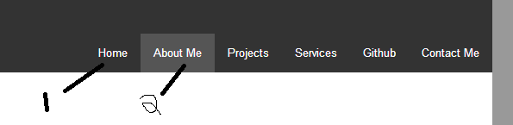

This is the navigation bar. It has links for all the different pages in my site. #1 is how a nav button looks normally and #2 is how a nav button looks when you hover over it.

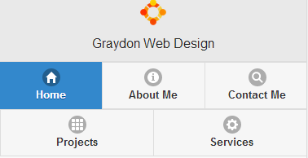

This is the mobile nav bar. The buttons are blue when they are selected. Instead of using image buttons for the projects and services, I instead added a second navbar under the first to make the site easier to navigate.

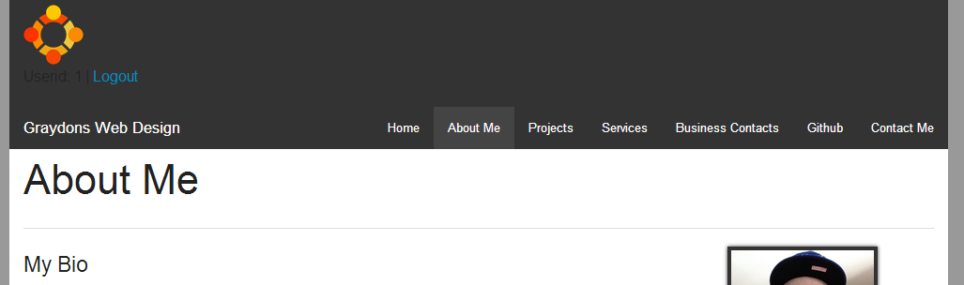

Here is the new nav bar that has been updated for assignment 3. I added the business contacts button to the nav bar and the login/logout links with userid under the logo on the left.

## Colours Section

For the mobile site I made a custom themeroller that incorporates the colors I used in my full site.

|  |  |
| --- | --- |
| Body Colour | #999999 |
| Main Content Area | #FFFFFF |
| Header & Footer & Nav Button | #333333 |
| Nav Button Hover | #444444 |
| Nav Button Current Page | #444444 |
| Nav Button Current Page Hover | #555555 |

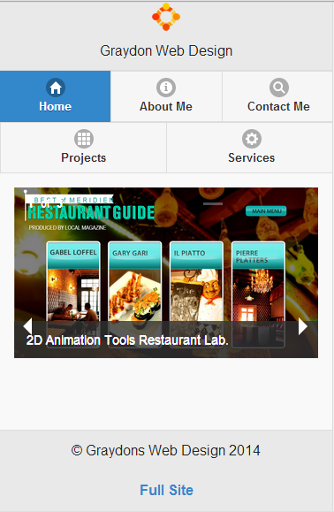

Here is a snapshot of the theme for mobile

## Typography Section

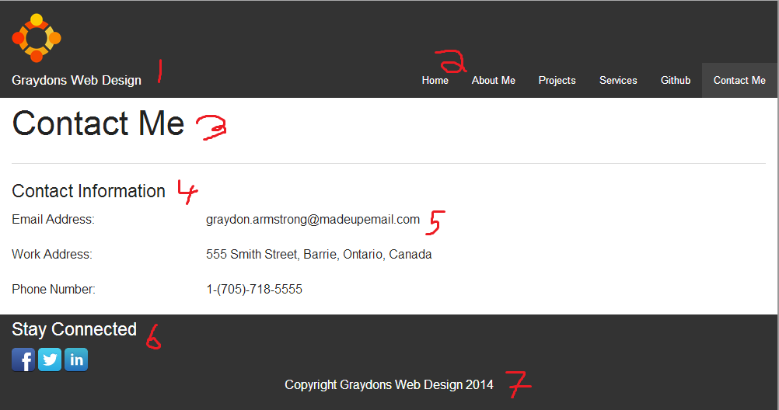

|  |  |  |  |
| --- | --- | --- | --- |
|  | Font | Size | Color |
| 1 | "Helvetica Neue", "Helvetica", Helvetica, Arial, sans-serif; | 1rem | #FFFFFF |
| 2 | "Helvetica Neue", "Helvetica", Helvetica, Arial, sans-serif; | 1rem | #FFFFFF |
| 3 | "Helvetica Neue", "Helvetica", Helvetica, Arial, sans-serif; | 2.125rem | #000000 |
| 4 | "Helvetica Neue", "Helvetica", Helvetica, Arial, sans-serif; | 1.125rem | #000000 |
| 5 | "Helvetica Neue", "Helvetica", Helvetica, Arial, sans-serif; | 1rem | #000000 |
| 6 | "Helvetica Neue", "Helvetica", Helvetica, Arial, sans-serif; | 1.125rem | #FFFFFF |
| 7 | "Helvetica Neue", "Helvetica", Helvetica, Arial, sans-serif; | 1rem | #FFFFFF |
|  |  |  |  |

The mobile site uses the google font Open Sans.



Uses the same fonts and Sizes as the main site

## Wireframes Section

### Home Page

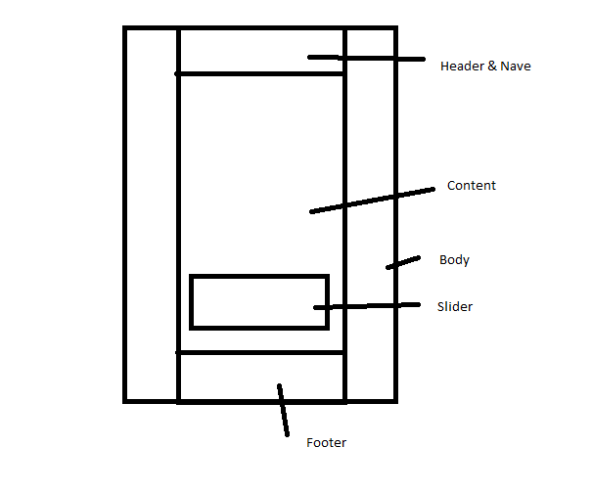

### About Me

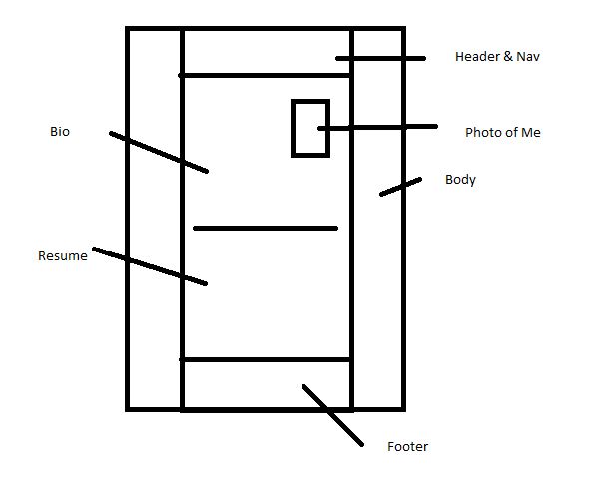

### Projects

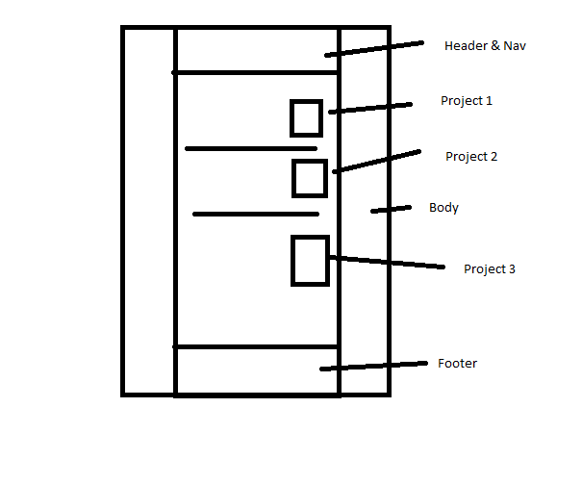

### Services

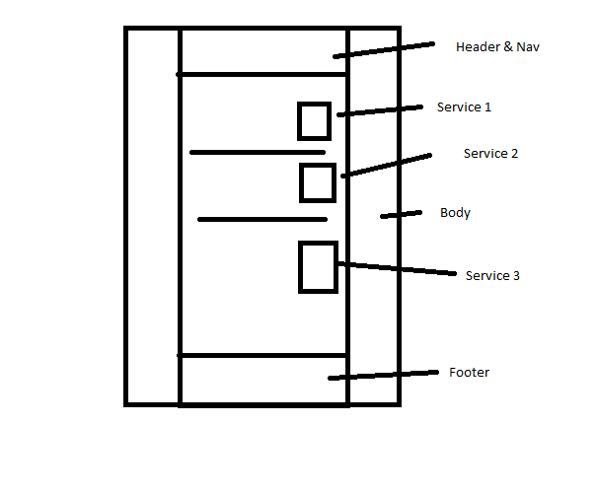

### Contact Me

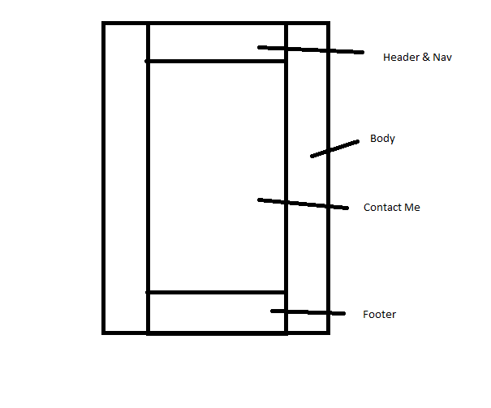

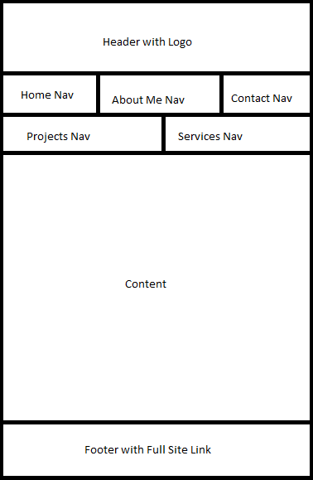

Mobile Wireframe

## Branding Section

### Screenshots

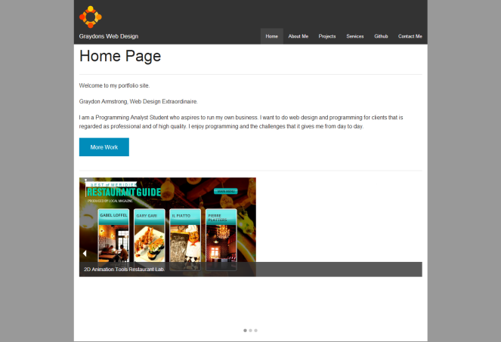 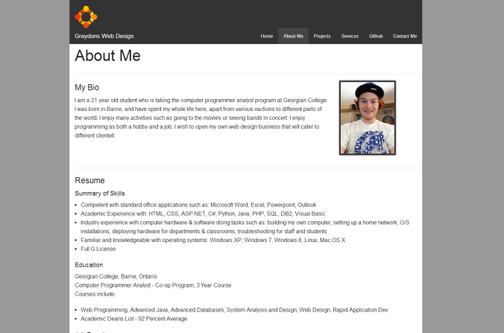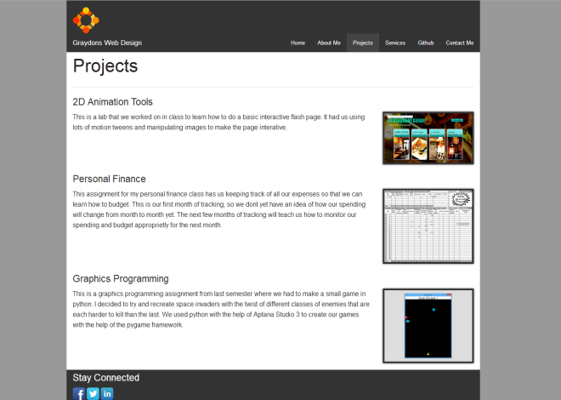 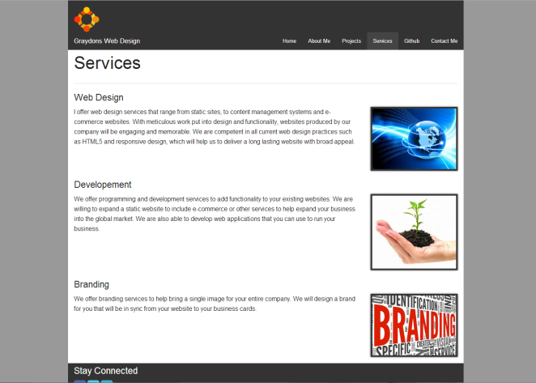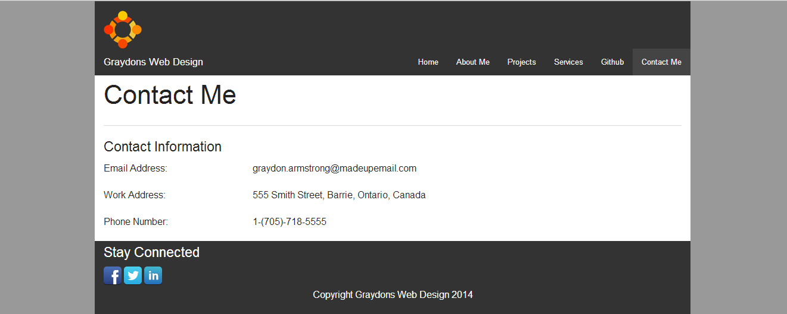



### Logo

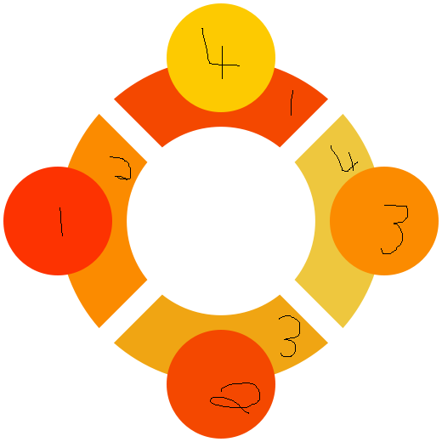

|  |  |
| --- | --- |
| Number | Hex |
| 1 | #FD3301 |
| 2 | #F44800 |
| 3 | #FB8B00 |
| 4 | #FDCA01 |